

American International University-Bangladesh (AIUB)  
Department of Computer Science  
Faculty of Science &Technology (FST)  
Summer 21-22

Section: A  
Software Quality Assurance and Testing

Bohemian -Your Travel Guide

A Report submitted

By

|  |  |  |
| --- | --- | --- |
| SN | Student Name | Student ID |
| 1 | Md. Ahsan Nayem | 19-41212-2 |
| 2 | Syeda Fariha Sultana | 19-39718-1 |
| 3 | Prisila Saha | 19-39759-1 |

Under the supervision of

ABHIJIT BHOWMIK

Associate Professor

Software Test Plan

for

<Bohemian -Your Travel Guide>

Version 1.0 approved

Prepared by < MD. AHSAN NAYEM >

< PRISILA SAHA >

< SYEDA FARIHA SULTANA >

<AMERICAN INTERNATIONAL UNIVERSITY -BANGLADESH (AIUB)>

<10 AUGUST 2022>

**Checked By Industry Personnel**

Name:

Designation:

Company:

Sign:

Date:

Table of Contents

Revision History 3

1. TEST PLAN IDENTIFIER: RS-MTP01.3 3

2. REFERENCES 3

3. INTRODUCTION 3

Background to the Problem 4

Solution to the Problem 5

4. REQUEIREMNT SPECIFICATION 5

4.1 System Features 5

4.2 System Quality Attributes 9

4.3 System Interface 10

4.4 Project Requirements 12

5. FEATURES NOT TO BE TESTED 13

6. TESTING APPROACH 14

6.1 Testing Levels 14

6.2 Test Tools 15

6.3 Meetings 17

7. TEST CASES/TEST ITEMS 17

8. ITEM PASS/FAIL CRITERIA 28

9. TEST DELIVERABLES 29

10. STAFFING AND TRAINING NEEDS 29

11. RESPONSIBILITIES 29

12. TESTING SCHEDULE 30

13. PLANNING RISKS AND CONTINGENCIES 31

14. APROVALS 31

# Revision History

|  |  |  |  |
| --- | --- | --- | --- |
| Revision | Date | Updated by | Update Comments |
| 0.1 | 2022.08.07 | Md Ahsan Nayem | First Draft |
| 0.2 | 2022.08.08 | Syeda Fariha Sultana | Second Draft |
| 0.3 | 2022.08.09 | Prisila Saha | Third Draft |
| 0.4 | 2022.08.10 | Md Ahsan Nayem | Fourth Draft |
| 0.5 | 2022.08.11 | Prisila Saha | Fifth Draft |
| 0.6 | 2022.08.12 | Syeda Fariha Sultana | Sixth Draft |
| 0.7 | 2022.08.13 | Md Ahsan Nayem | Seventh Draft |
| 0.8 | 2022.08.16 | Prisila Saha | Eighth Draft |
| 0.9 | 2022.08.18 | Syeda Fariha Sultana | Nineth Draft |

# TEST PLAN IDENTIFIER:RS-MTP01.3

# REFERENCES

[1] [[Tourism in Bangladesh - Wikipedia](https://en.wikipedia.org/wiki/Tourism_in_Bangladesh)](https://bn.wikipedia.org/wiki/%E0%A6%AC%E0%A6%BE%E0%A6%82%E0%A6%B2%E0%A6%BE%E0%A6%A6%E0%A7%87%E0%A6%B6%E0%A7%87%E0%A6%B0_%E0%A6%AA%E0%A6%B0%E0%A7%8D%E0%A6%AF%E0%A6%9F%E0%A6%A8#%E0%A6%85%E0%A6%B0%E0%A7%8D%E0%A6%A5%E0%A6%A8%E0%A7%88%E0%A6%A4%E0%A6%BF%E0%A6%95_%E0%A6%AA%E0%A7%8D%E0%A6%B0%E0%A6%AD%E0%A6%BE%E0%A6%AC)

[2] <http://www.tourismboard.gov.bd/>

[3] [App Builder | Industry Leading App Maker for iOS & Android Mobile Apps (buildfire.com)](https://buildfire.com/)

[4] https://highways.dot.gov/

# INTRODUCTION

The natural splendor of Bangladesh has long captivated tourists. In Bangladesh, a country of such beauty, there is obviously great potential for the growth of the tourism sector. By utilizing all available opportunities and implementing novel tactics, Bangladesh can serve as a role model for South Asian tourism. Despite being a small nation, Bangladesh has a wide range of tourism sites that can readily draw visitors. If the nation's tourism industry grows, jobs will be produced and poverty will be reduced by doing away with unemployment. The country's tourism industry contributed 3.02 percent of the GDP in 2018–2019. In local currency, it comes to around BDT 76,690 crore. 8.07% of all job openings are being produced by this industry. More than 500,000 foreign visitors came to Bangladesh in 2019. 1.3 million Bangladeshi visitors traveled abroad at the same time. Over two million tourists have come to the nation. The country's tourist industry directly employs roughly 1.5 million people. 23,000,000 indirectly. About 40 lakh people have been employed directly and indirectly in this industry, which has an estimated financial value of BDT 4,000 crore [1]. This sector needs a digital system to create a tourism-friendly environment and assist tourists. Which will be simple, user friendly and modernized which will be helpful for domestic and foreign tourists.

## Background to the Problem

* A common problem of tourists is that they don't know about all the tourist spots of Bangladesh, how to go where? are there any hotels or restaurants? What will the weather be like when he wants to travel? What is their transportation system? Are there hospitals, police stations, airports, and river ports nearby? They experience many other such problems. Due to these problems, many people express reluctance to go on tour. A well-optimized system or a platform can overcome these disadvantages as well as add a different dimension. Which is undoubtedly able to expand and modernize the country's tourism industry.

## Solution to the Problem

* We are going to create a platform to serve as every traveler's query and assistance, where it will represent tourist attraction and provide information about its location, surroundings, weather, and all like a suitable guide. As a result, tourists will have easier access to information about any tourist attraction and will find it simpler to make tour plans and related preparations, which will boost the tourism sector. The software's goals are to lower travel expenses, save time, provide safety, and enable flexible communication. For the users, the software will act as a tour guide. The software's goal will be to give tourists a hassle-free and enjoyable trip. The software's ultimate objective is to give tourists a tool that can help them save money and time.
* Through the proposed system a user can i) view the list of all tourist destinations. ii) Know about the exact time to visit the tourist center. iii) User can be informed about important and necessary installations in the vicinity. iv) User shall know the incidental cost of stay as per his intention. v) Communicate with other users of the system. vi) Can share the experience of any tourist center. vii) Users can plan tours and make them open to everyone. They can organize tours with interested people.
* There are scattered maps, hotel booking apps, transport ticket booking websites, weather apps, but there is nowhere to configure all these important features on the same platform as per the needs of a tourist. There are some existing systems but their functionality and features are very limited and not widely used freely. This platform offers more and more modern features than them.

# REQUEIREMNT SPECIFICATION

## System Features

1. **System Login**

Functional Requirements

* 1. The software shall allow users to login with their given username and password
  2. If the username and/or password has been inserted wrong for more than three times, the random verification code will be generated by the system to retry login.
  3. If the number of login attempt exceed its limit (5 times), the system shall block the user account login for one hour *[optional function]*

Priority Level: High  
Precondition: user have valid user id and password

1. **User details**

Functional Requirements

* 1. User can Show his information from here
  2. User can update his information
  3. To confirm update information user needs to type password

Priority level: Medium

Precondition: User can successfully login.

1. **Tourist spot list**

Functional Requirements

* 1. Tourist can see all spot list of Bangladesh
  2. By click spot name he can see details about spot
  3. Relevant pictures history and important information about spot should be given.

Priority Level: Low  
Precondition: N/A

1. **Map**

Functional Requirements

* 1. The system map initially indicates all tourist spot on the map
  2. If select any spot, then it will enlarge and additional features will open.
  3. User can see route direction by using his current location.
  4. Besides it shows nearby hotel, restaurant, station, hospital of selected spot.
  5. User can search any specific spot/place from map search bar.

Priority Level: Medium  
Precondition: Map features integrated properly

1. **Weather forecast**

Functional Requirements

* 1. The software has weather forecast feature.
  2. It shows daily weather update
  3. User can show his desire dates forecast
  4. IF event date has any natural calamities

Priority Level: High  
Precondition: N/A

1. **Community**

Functional Requirements

* 1. User can search another user by name
  2. User can get connected with others by both approval
  3. They can make group with multiple members.
  4. In community they can share their thoughts, chat with each other.

Priority level: Medium

Precondition: Chatting and other writing section should be developed.

1. **Event**

Functional Requirements

* 1. The system allows user to create an event.
  2. Event contains a detail, event time and place.
  3. Other user can interest this event by clicking interest button.
  4. Interested people can make event together.

Priority level: Medium

Precondition: Community section should be developed.

1. **Review**

Functional Requirements

* 1. User can write his thought about any specific place.
  2. If user face any difficulties, he can aware another by review.
  3. User can add photo here.

Priority level: Medium

Precondition: User can successfully login.

1. **Budget Estimation**

Functional Requirements

* 1. Basically, this works like a calculator with some extra features.
  2. It calculates user selected hotel and transportation cost automatically.
  3. User select input manually how many days he wants to stay in hotel, what kind of transportation he prefers system will calculate those cost.

Priority level: High

Precondition: Hotel and transportation information should include.

1. **Booking**

Functional Requirements

* 1. By this system user can search hotel, restaurant and transportation system.
  2. If user select any specific spot system automatically show nearby hotel, restaurant and transportation system.
  3. User can see information by clicking those and book.

Priority level: High

Precondition: User has online payment resource.

1. **Logout**

Functional Requirements

* 1. By click this system logged out his account.
  2. Remove user session.
  3. Get back login page.

Priority level: High

Precondition: User has valid id.

## System Quality Attributes

* **Usability:**

The user interface of the system should be simple and easy. Even new users can understand what is there by looking at the symbols and text. Any operation for a new user should not take more than 3 minutes.

* **Maintainability:**

There should be scope for system change amplification and correction in any emerging situation. A maintenance programmer shall be able to modify existing feature to make change or correct any feature with 08 labor hours or less of development effort.

* **Reliability:**

The operation for which the user performs the action must be 100% correct.No more than 2 experimental runs out of 1000 can be lost because of software failures.

* **Efficiency:**

The system should work very quickly and smoothly. Do not put excessive pressure on the device while running the system. At least 50 percent of the processor capacity and RAM available to the application shall be unused at the planned peak load conditions.

* **Integrity/Security:**

Stay safe from various security threats and attacks. If someone tries to enter illegally, it will be identified and blocked. Access to personal information will be controlled by the individual himself.

* **Flexibility:**

This system will be very flexible. A maintenance programmer with at least one month of experience supporting this product should be able to provide a fresh copy of the output for the product, including code changes and testing, with no more than one hour of labor.

* **Testability:**

Testing team must need easily perform their task. Testability is very much depended on modularity. A module's cyclomatic complexity* cannot be more than 20.

* **Reusability:**

Map structure input functions shall be designed to be reusable at the object code level in other applications that use the finding structure representations.

## System Interface

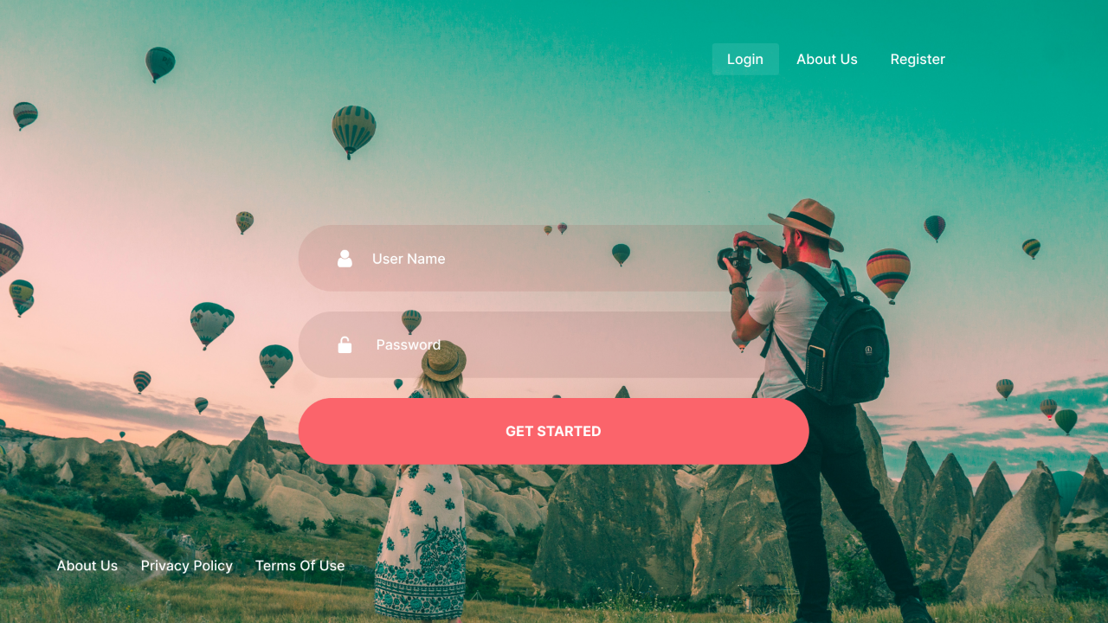

Fig: Login Interface

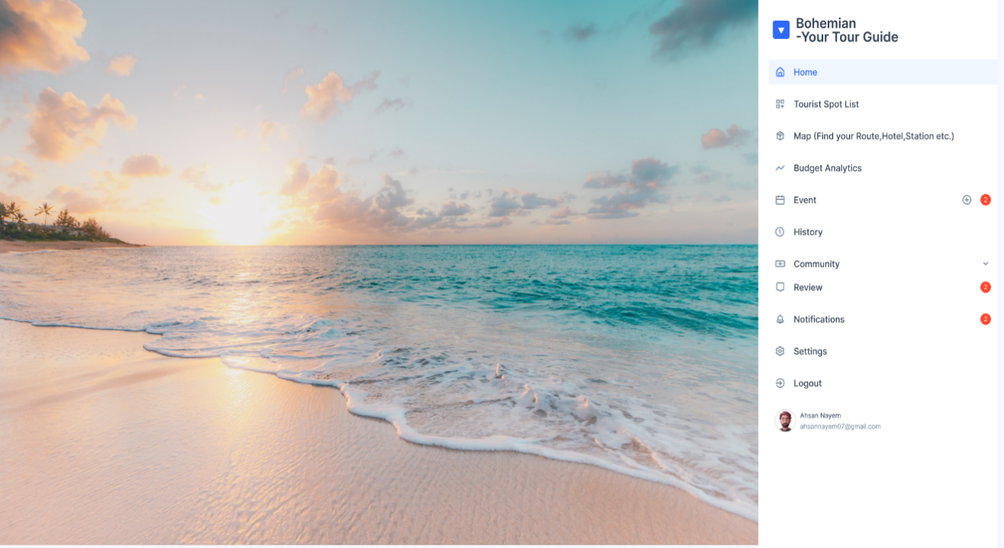



Fig: Homepage Interface

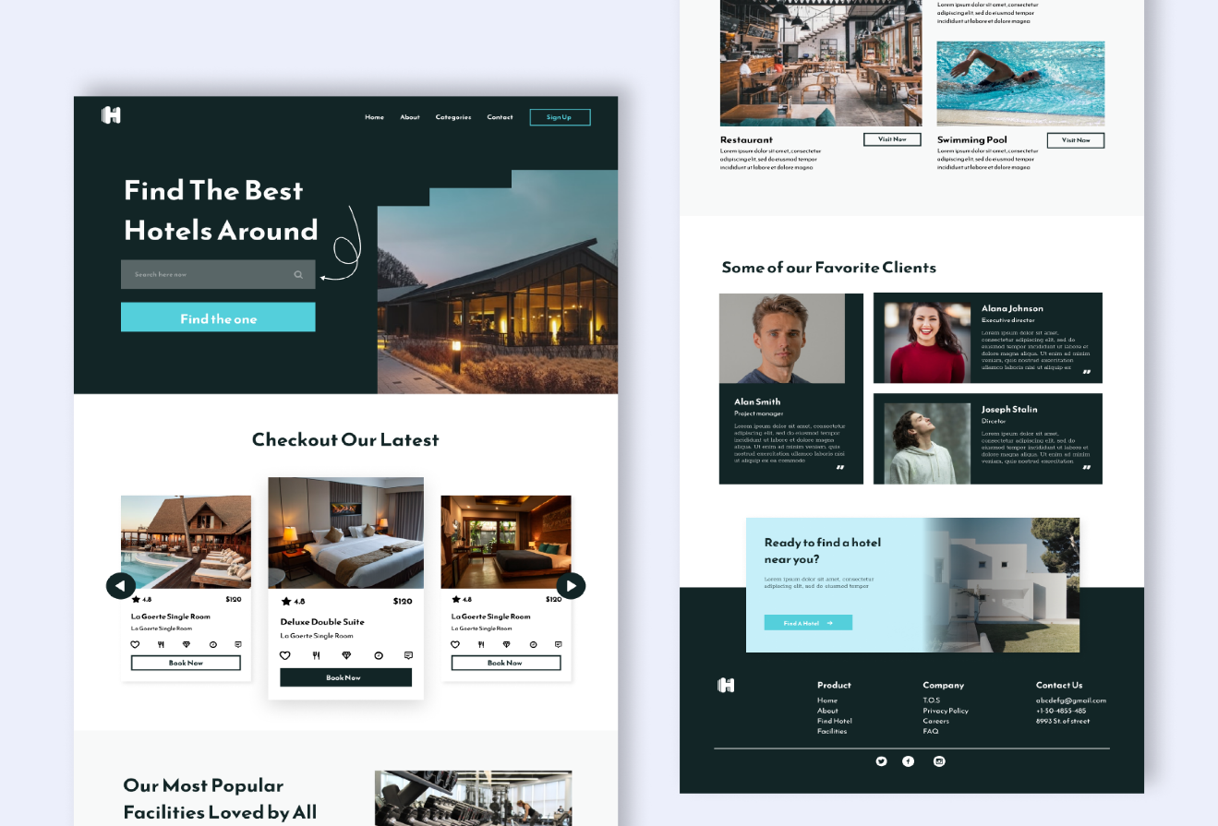



Fig: Hotel Booking Interface

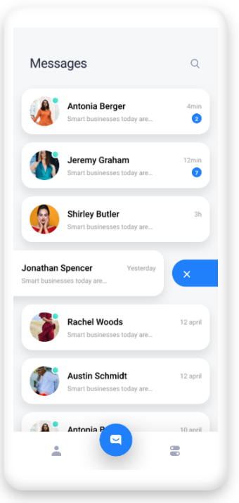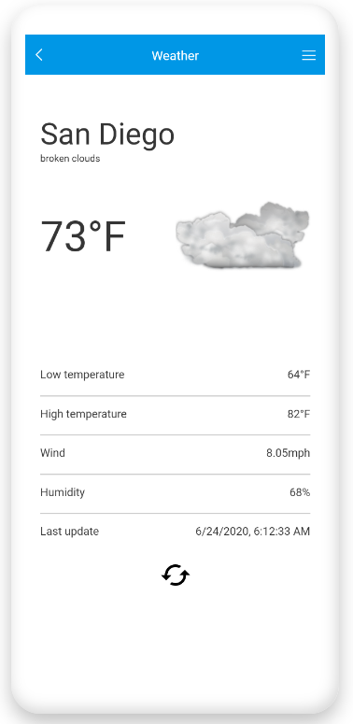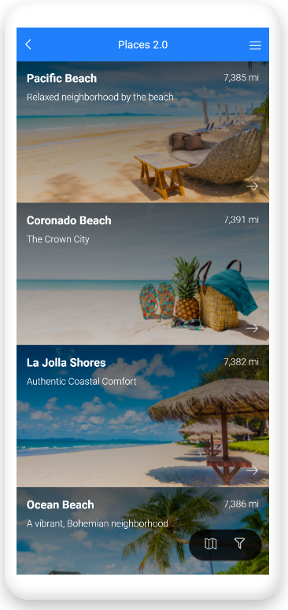



Fig: Spot List Fig: Weather Forecast Fig: Chat

## Project Requirements

* The list of project restrictions (including those related to time, money, resources, and the environment) that must be adhered to during project management is provided below, along with calculations.

|  |  |  |  |
| --- | --- | --- | --- |
| **Item Name** | **Setup Cost** | **Development Cost** | **Monthly servers/services Cost** |
| Google Android | - | 160 hours * BDT 60 =  BDT 9600 | - |
| Web APP | 32 hours * BDT 60 =  BDT 1920 | 160 hours * BDT 60 =  BDT 9600 | BDT 60 |
| Map a list of location | 32 hours * BDT 30 =  BDT 960 | 120 hours * BDT 60 =  BDT 7200 | - |
| See or Book Calendar Events | - | 120 hours * BDT 60 =  BDT 7200 | - |
| Weather | 96 hours * BDT 30 =  BDT 2880 | 64 hours * BDT 60 =  BDT 3840 | BDT 60 |
| Chat and message Boards | - | 64 hours * BDT 60 =  BDT 3840 | - |
| Social Media | - | 75 hours * BDT 60 =  BDT 4500 | - |
| Image Gallery | - | 200 hours * BDT 60 =  BDT 12000 | - |
| Fill and Submit Forms | 16 hours * BDT 30 =  BDT 480 | 16 hours * BDT 60 =  BDT 960 | - |
| Book Appointments and Reservations | - | 64 hours * BDT 60 =  BDT 3840 | - |
| Customer Feedback | - | 250 hours * BDT 60 =  BDT 15000 | - |
| Send Push Notifications | 40 hours * BDT 30 =  BDT 1200 | 480 hours * BDT 60 =  BDT 28800 | BDT 100 |
| Email | 160 hours * BDT 30 =  BDT 4800 | 64 hours * BDT 60 =  BDT 3840 | BDT 100 |
| User Profile | 48 hours * BDT 30 =  BDT 1440 | 80 hours * BDT 60 =  BDT 4800 | BDT 60 |
| Camera (Image, Video) | 8 hours * BDT 30 =  BDT 240 | 40 hours * BDT 60 =  BDT 2400 | - |
| SDK | 80 hours * BDT 30 =  BDT 2400 | 480 hours * BDT 60 =  BDT 28800 | - |
| Publics API’s | 80 hours * BDT 30 =  BDT 2400 | 480 hours * BDT 60 =  BDT 28800 | BDT 300 |
| Growth Plan | - | - | - |
| Free | - | - | - |
| Setup & Design Packages | - | - | BDT 4500 |
| Host and develop | - | - | BDT 4500 |
| **Total** | **BDT 18,720** | **BDT 175,020** | **BDT 9,680** |
|  |  |  |  |

Total Cost = (18,720 + 175,020 + 9,680) = 203420 BDT

Total Development Time 4 Months 25 Days (3477 hours)

# FEATURES NOT TO BE TESTED

The following is a list of the areas that will not be specifically addressed. All testing in these areas will be indirect as a result of other testing efforts. For example:

* To ensure system reliability and quality work Almost all features are required and important to test. Google Maps is used as the map which is reliable and uncompromised, so this feature test is not required.
* About section is a paragraph of developer companies. It needs not to be tested.
* Privacy Policy is a notice section of legal and illegal work for this system. Besides its aware user also. Here state law and authority law are stated. It not to be tested.
* Terms of use is a user manual here stated how to use. So, this section also doesn’t need to test.

# TESTING APPROACH

A few procedures will be followed for testing the complete system.

Unit testing:

The development team leader will give the developer permission to undertake UNIT testing. Unit testing must be shown by the programmer before it can be accepted and forwarded to the tester (test case list, sample output, data printouts, defect information). All unit test information will also be provided to the test subject. During unit testing, each module of the system will be tested independently. As a result, every feature of the system—including GPS, Events, Making Your Groups, Login, and Choosing Best Route—will be put to the test separately.

Integration testing:

Testing will be done by the test manager and development team leader, with support from individual developers as needed. There are no specialized test tools available for this project. A System/Integration test will be performed on the programs when all critical flaws have been fixed. As long as the problems do not prohibit the program from being tested, a program may have up to two significant flaws. The entire App system is put through system testing. It makes it possible to check whether the system complies with the standards. It investigates how the various components interact overall. The procedure includes load, performance, reliability, and security testing. In this step, various modules will be connected.

System testing:

After combining all the modules, a complete system will be created. A thick system will be tested to check whether the complete system is able to fulfill its requirements together, is working correctly, is providing correct output against specific inputs.

Acceptance testing:

With assistance from the test manager and development team leader, actual end users will conduct the testing. For one month following the conclusion of the System/Integration test, the acceptance test will coexist with the currently used manual procedure. The development team does internal acceptability testing first, as seen by the client. The application is presented to users for official acceptance testing if the developer team is pleased. If the software satisfies the client's expectations, they approve it with or without agreeing to the implementation of certain future requirements.

Beta testing:

Sometimes some software releases a free version to get user complaints, suggestions and feedback before releasing it. This version or testing process is called beta testing. In this process, improvements are made based on user feedback.

## Testing Levels

* Bohemian-Your Tour Guide will undergo mainly four phases of testing: unit testing, integration testing, system testing, acceptance testing. System/integration testing shall be given at least one full-time independent test person's attention. The test manager will perform the majority of the testing with assistance from the development teams due to the financial and schedule constraints.
* The developer will conduct UNIT testing, which will be approved by the development team leader. Before unit testing may be accepted and passed on to the tester, the programmer must give proof of unit testing (test case list, sample output, data printouts, defect information). The test person will receive all unit test information as well. Each module of the system will be tested separately during unit testing. As a result, each of the system's functionalities, such as Choosing Best Route, Login, Events, Make Your Groups, Create Event, and GPS, will be tested individually.
* SYSTEM/INTEGRATION Testing will be performed by the test manager and development team leader with assistance from the individual developers as required. No specific test tools are available for this project. Programs will enter into System/Integration test after all critical defects have been corrected. A program may have up to two Major defects as long as they do not impede testing of the program (I.E. there is a work around for the error).
* ACCEPTANCE Testing will be performed by the actual end users with the assistance of the test manager and development team leader. The acceptance test will be done in parallel with the existing manual ZIP/FAX process for a period of one month after completion of the System/Integration test process.
* BETA just before launch the system it will open for customer for a beta testing and feedback.

## Test Tools

Selenium is an open-source project that serves as a hub for a variety of tools and frameworks that facilitate browser automation. It offers a playback tool so that functional tests may be created across the majority of current web browsers without the requirement to learn a test scripting language (Selenium IDE). Additionally, it offers a test domain-specific language (Selenese) that enables the writing of tests in a variety of well-known programming languages, such as JavaScript (Node.js), C#, Groovy, Java, Perl, PHP, Python, Ruby, and Scala. Windows, Linux, and macOS all support Selenium. Under the terms of the Apache License 2.0, it is open-source software. This is a great way to test software. To use it, we first need to set up a favorable environment. For this some necessary additional files need to be downloaded and installed. Implementation is shown here using Java.

* Selenium

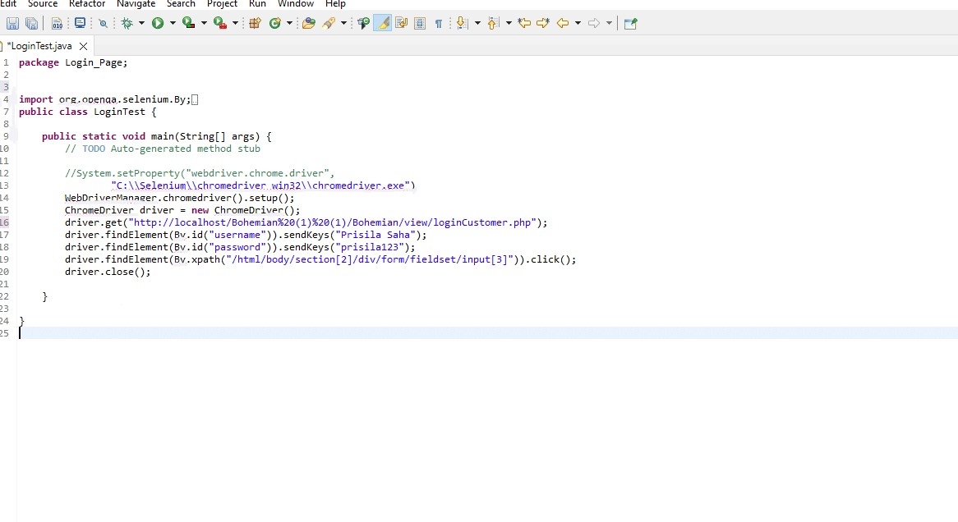

Fig: Testing instruction on Eclipse

We wrote the code in the class and imported selenium jar file and chromedriver.

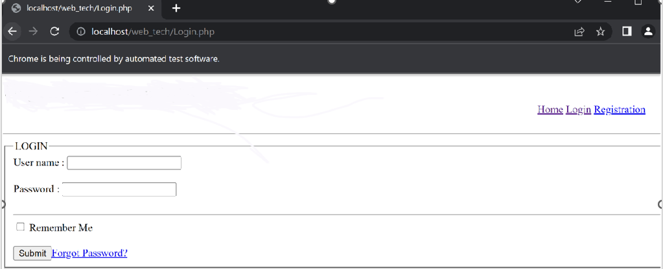 Fig: Test Result

Here the project run successfully and opened chrome server with login page.

Using the password for the first time, the username and password has been saved automatically by the debugging of the code. That’s why, after running the project, it’s automatically going to the homepage with logged username.

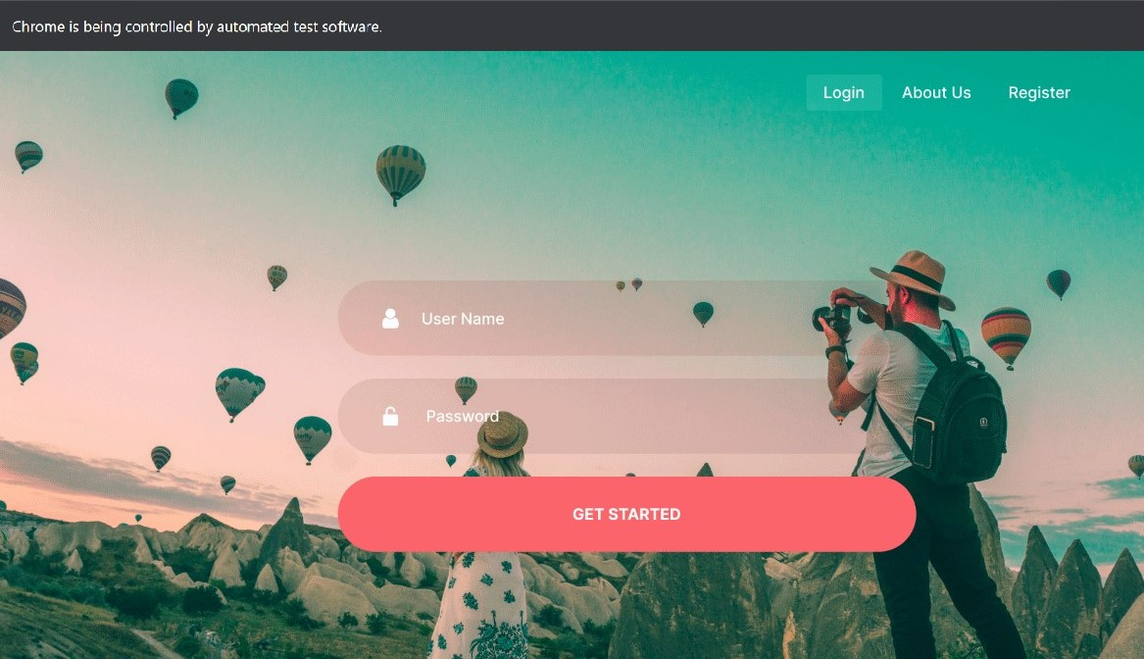Here, we can see the testing using selenium has been done successfully. We do this automation testing in our project Bohemian-Your Tour Guide login page too and here is the result.

Fig: Testing Result

## Meetings

One of the principal things to be a success testing team is to distribute the proper task to the proper person. So, with a purpose to be a success group doing normal group meeting is very essential. So, the take a look at group will meet as soon as in each week to evaluate the development of each member whether or not they have executed or doing their assigned work or no longer. And check whether they may be dealing with any hassle in the event that they face any hassle concerning checking out then different team will help him and try and remedy it as early as feasible. The team lead of trying out group will meet development and task manager as soon as in each week. More meeting could be organized if there is any emergency.

# TEST CASES/TEST ITEMS

**1.User login**

|  |  |  |  |  |  |
| --- | --- | --- | --- | --- | --- |
| **Project Name:** Bohemian-Your Travel Guide | | | **Test Designed by:**  Md. Ahsan Nayem | | |
| **Test Case ID:**  B-YTG_01 | | | **Test Designed date:** 10.08.2022 | | |
| **Test Priority (Low, Medium, High):** Medium | | | **Test Executed by**: Prisila Saha | | |
| **Module Name:** Login Session | | | **Test Execution date:** 11-08-2022 | | |
| **Test Title:** verify login with valid username and password | | |  | | |
| **Description:** Test the website login page. | | |  | | |
| **Precondition (If any):** User Must have to valid username and password. | | | | | |
| **Test Steps** | **Test Data** | **Expected Results** | | **Actual Results** | **Status (Pass/Fail)** |
| 1. Go to the website 2. Enter username 3. Enter password   4.Click submit | Username: ahsan@xyz.com  Password: 321 | User should login into the application | | As expected, | Pass |
| **Post Condition:** User is validated with database and successfully login to account. The account session details are logged in the database. | | | | | |

|  |  |  |  |  |  |
| --- | --- | --- | --- | --- | --- |
| **Project Name:** Bohemian-Your Travel Guide | | | **Test Designed by:** Syeda Fariha | | |
| **Test Case ID:**  B-YTG_02 | | | **Test Designed date:** 11-08-2022 | | |
| **Test Priority (Low, Medium, High):** Medium | | | **Test Executed by**: Syeda Fariha | | |
| **Module Name:** User detail session | | | **Test Execution date:** 12-08-2022 | | |
| **Test Title:** Verify the websites user detail page. | | |  | | |
| **Description:** Test the website and user detail page | | |  | | |
| **Precondition (If any):** User Must have to login into profile. | | | | | |
| **Test Steps** | **Test Data** | **Expected Results** | | **Actual Results** | **Status (Pass/Fail)** |
| 1. go to the site  2. enter username  3. enter password  4. click user detail button | Username: ahsan@xyz.com  Password=321 | Successful users see their detail | | As expected, | Pass |
| **Post Condition:** The updated user details stored in the database | | | | | |

**2.User Detail**

|  |  |  |  |  |  |
| --- | --- | --- | --- | --- | --- |
| **Project Name:** Bohemian-Your Travel Guide | | | **Test Designed by:** Syeda Fariha | | |
| **Test Case ID:**  changePassword_04 | | | **Test Designed date:** 12-08-2022 | | |
| **Test Priority (Low, Medium, High):** Low | | | **Test Executed by**: Prisila Saha | | |
| **Module Name:** Tourist spot list showing Session | | | **Test Execution date:** 13-08-2022 | | |
| **Test Title:**  verify enter the website. | | |  | | |
| **Description:** Test website page. | | |  | | |
| **Precondition (If any):** N/A | | | | | |
| **Test Steps** | **Test Data** | **Expected Results** | | **Actual Results** | **Status (Pass/Fail)** |
| 1. go to the site  2. Enter the tourist spot list page. |  | User or tourist show the list of spots. | | As expected, | Pass |
| **Post Condition:** User or tourists show the list of places. | | | | | |

**3.Tourist spot list**

|  |  |  |  |  |  |
| --- | --- | --- | --- | --- | --- |
| **Project Name:** Bohemian-Your Travel Guide | | | **Test Designed by:** Syeda Fariha | | |
| **Test Case ID:**  B-YTG_04 | | | **Test Designed date:** 12-08-2022 | | |
| **Test Priority (Low, Medium, High):** High | | | **Test Executed by**: Syeda Fariha | | |
| **Module Name:** Map direction of tourist spot showing Session | | | **Test Execution date:** 13-08-2022 | | |
| **Test Title:**  verify enter the website and check the map. | | |  | | |
| **Description:** Test website page and check direction of map | | |  | | |
| **Precondition (If any):** Map features integrated properly | | | | | |
| **Test Steps** | **Test Data** | **Expected Results** | | **Actual Results** | **Status (Pass/Fail)** |
| 1. go to the site  2. Enter the Map.  3.Click the spot.  4. check direction of map | Check current location  Check Map and additional data | User or tourist show the direction and information of spots. | | As expected, | Pass |
| **Post Condition:** User or tourists get direction and additional information on Map. | | | | | |

**4.Map**

|  |  |  |  |  |  |
| --- | --- | --- | --- | --- | --- |
| **Project Name:** Bohemian-Your Travel Guide | | | **Test Designed by:** Syeda Fariha | | |
| **Test Case ID:**  B-YTG_05 | | | **Test Designed date:** 14-08-2022 | | |
| **Test Priority (Low, Medium, High):** High | | | **Test Executed by**: Md. Ahsan | | |
| **Module Name:** Weather Forecasting Session | | | **Test Execution date:** 15-08-2022 | | |
| **Test Title:**  verify enter the website and check weather. | | |  | | |
| **Description:** Test website’s weather forecasting page. | | |  | | |
| **Precondition (If any):** N/A | | | | | |
| **Test Steps** | **Test Data** | **Expected Results** | | **Actual Results** | **Status (Pass/Fail)** |
| 1. go to the site  2. Enter the weather forecast.  3. click the desire date  4. check weather | Check the current date.  Check desire date’s weather | User or tourist show the information about weather. | | As expected, | Pass |
| **Post Condition:** User or tourists get information about weather update. | | | | | |

**5.Weather forecast**

|  |  |  |  |  |  |
| --- | --- | --- | --- | --- | --- |
| **Project Name:** Bohemian-Your Travel Guide | | | **Test Designed by:** Md. Ahsan Nayem | | |
| **Test Case ID:**  B-YTG_02 | | | **Test Designed date:** 16-08-2022 | | |
| **Test Priority (Low, Medium, High):** High | | | **Test Executed by**: Prisila Saha | | |
| **Module Name:** Community | | | **Test Execution date:** 17-08-2022 | | |
| **Test Title:**  User can make community with other users. | | |  | | |
| **Description:** Test the user can make community, can chat with other group members in group. | | |  | | |
| **Precondition (If any):** User need to connect with others. | | | | | |
| **Test Steps** | **Test Data** | **Expected Results** | | **Actual Results** | **Status (Pass/Fail)** |
| 1. go to community  2. choose person and make group  3. chat with others  4. add member  5.request approval | Chatting with others in personal in group. | User should chat with others in personal or in group. | | As expected, | Pass |
| **Post Condition:** User chats with other group members in personal or in group. | | | | | |

**6.Community**

|  |  |  |  |  |  |
| --- | --- | --- | --- | --- | --- |
| **Project Name:** Recycle Trash | | | **Test Designed by:** Md. Abu Torab Ibnul Baki | | |
| **Test Case ID:**  changePassword_04 | | | **Test Designed date:** 13-04-2022 | | |
| **Test Priority (Low, Medium, High):** High | | | **Test Executed by**: Md. Abu Torab Ibnul Baki | | |
| **Module Name:** Update Password | | | **Test Execution date:** 15-04-2022 | | |
| **Test Title:**  Can change password from the profile. | | |  | | |
| **Description:** Test password is update or not. | | |  | | |
| **Precondition (If any):** User Must have to login into profile. | | | | | |
| **Test Steps** | **Test Data** | **Expected Results** | | **Actual Results** | **Status (Pass/Fail)** |
| 1. go to the site  2. log in to the site  3. write new password to the input field  4. click change password button | New Password=1#4$dy$ | Successful update password | | As expected, | Pass |
| **Post Condition:** The updated password is stored in the database | | | | | |

|  |  |  |  |  |  |
| --- | --- | --- | --- | --- | --- |
| **Project Name:** Bohemian-Your Travel Guide | | | **Test Designed by:** Syeda Fariha | | |
| **Test Case ID:**  B-YTG_07 | | | **Test Designed date:** 16-08-2022 | | |
| **Test Priority (Low, Medium, High):** Medium | | | **Test Executed by**: Syeda Fariha | | |
| **Module Name:** Event Session | | | **Test Execution date:** 17-08-2022 | | |
| **Test Title:** verify the website and check the event site. | | |  | | |
| **Description:** Test the websites event page. | | |  | | |
| **Precondition (If any):** User Must have to login with valid id and password | | | | | |
| **Test Steps** | **Test Data** | **Expected Results** | | **Actual Results** | **Status (Pass/Fail)** |
| 1. go to the website  2. log in to the site  3.click event section  4. click create event  5.click ok | Username: ahsan@xyz.com  Password=321  Check group information and event information | User or tourist can create event and make event each other. | | As expected, | Pass |
| **Post Condition:** User or tourists can communicate with other users. | | | | | |

**7.Event**

|  |  |  |  |  |  |
| --- | --- | --- | --- | --- | --- |
| **Project Name:** Bohemian-Your Travel Guide | | | **Test Designed by:** Syeda Fariha | | |
| **Test Case ID:**  B-YTG_08 | | | **Test Designed date:** 19-08-2022 | | |
| **Test Priority (Low, Medium, High):** Medium | | | **Test Executed by**: Md Ahsan Nayem | | |
| **Module Name:** Review Session | | | **Test Execution date:** 19-08-2022 | | |
| **Test Title:**  Go to the website and verify the review site. | | |  | | |
| **Description:** Test website’s review site. | | |  | | |
| **Precondition (If any):** User must have to login with valid id and password. | | | | | |
| **Test Steps** | **Test Data** | **Expected Results** | | **Actual Results** | **Status (Pass/Fail)** |
| 1. go to the website  2. log in to the site  3.click review page.  4.check review message option  5.Click submit. | Username: ahsan@xyz.com  Password=321  Check users’ information which added. | Users write their review and see others review. | | As expected, | Pass |
| **Post Condition:** Users information and review included in database. | | | | | |

**8.Review**

|  |  |  |  |  |  |
| --- | --- | --- | --- | --- | --- |
| **Project Name:** Bohemian-Your Travel Guide | | | **Test Designed by:** Prsila Saha | | |
| **Test Case ID:**  changePassword_04 | | | **Test Designed date:** 18-08-2022 | | |
| **Test Priority (Low, Medium, High):** High | | | **Test Executed by**: Prisila Saha | | |
| **Module Name:** Budget estimation Session | | | **Test Execution date:** 19-08-2022 | | |
| **Test Title:**  Verify the budget estimation page | | |  | | |
| **Description:** Test that user can calculate estimation of travel with calculator. | | |  | | |
| **Precondition (If any):** Hotel and transportation information should include. | | | | | |
| **Test Steps** | **Test Data** | **Expected Results** | | **Actual Results** | **Status (Pass/Fail)** |
| 1. go to the website  2. log in to the site  3. click the budget estimation  4. check cost option  5.click calculate. | Check users’ information of costing which added. | Users write their cost and see calculation | | As expected, | Pass |
| **Post Condition:** Users calculate their costing estimation. | | | | | |

**9.Budget Estimation**

|  |  |  |  |  |  |
| --- | --- | --- | --- | --- | --- |
| **Project Name:** Bohemian-Your Travel Guide | | | **Test Designed by:** Prisila Saha | | |
| **Test Case ID:**  B-YTG_10 | | | **Test Designed date:** 18-08-2022 | | |
| **Test Priority (Low, Medium, High):** High | | | **Test Executed by**: Prisila Saha | | |
| **Module Name:** Booking Session | | | **Test Execution date:** 19-08-2022 | | |
| **Test Title:**  Verify the booking page. | | |  | | |
| **Description:** Test that user can booked their destination spot. | | |  | | |
| **Precondition (If any):** User should have online payment system resources. | | | | | |
| **Test Steps** | **Test Data** | **Expected Results** | | **Actual Results** | **Status (Pass/Fail)** |
| 1. go to the website  2. log in to the site  3.Go to booking page  4.check the destination  5.click payment  6.click booked | Check users’ booking and payment system. | Users select destination and select payment. | | As expected, | Pass |
| **Post Condition:** Users book their destination and payment on online. | | | | | |

**10.Booking**

|  |  |  |  |  |  |
| --- | --- | --- | --- | --- | --- |
| **Project Name:** Bohemian-Your Travel Guide | | | **Test Designed by:** Prisila Saha | | |
| **Test Case ID:**  B-YTG_11 | | | **Test Designed date:** 18-08-2022 | | |
| **Test Priority (Low, Medium, High):** High | | | **Test Executed by**: Prisila Saha | | |
| **Module Name:** Logout Session | | | **Test Execution date:** 19-08-2022 | | |
| **Test Title:**  Verify the logout page. | | |  | | |
| **Description:** Test the website logout page | | |  | | |
| **Precondition (If any):** User Must have to login with valid id and password. | | | | | |
| **Test Steps** | **Test Data** | **Expected Results** | | **Actual Results** | **Status (Pass/Fail)** |
| 1. go to the site  2. log in to the site  3. Go to logout page  4. click Logout button | Username: ahsan@xyz.com  Password=321 | Users should logout onto the application | | As expected, | Pass |
| **Post Condition:** Users is validated with database and successfully logout to account. The account session detail is logout from the database. | | | | | |

**11.Logout**

# ITEM PASS/FAIL CRITERIA

Each test phase should be described in test procedures. They must specify the requirement (or portion of a requirement) that is being verified, the action, event, or condition that must take place in order to carry out or finish the test step, and the anticipated result or reaction to that action. The pass/fail standard for that step is the anticipated outcome (or response). The test step can be said to have succeeded and the test step's requirement is confirmed if it was carried out, the anticipated result occurred, and it could be verified through observation or recording. The test step must be deemed to have failed and the requirement must not have been verified if it could not be performed or could be performed but the expected result did not occur, could not be witnessed, or could not be verified from the record. Any result that differs from what was anticipated should be regarded as an anomaly or error.

# TEST DELIVERABLES

* Test strategy.
* Test plan and estimation.
* Test scenario.
* Test cases and test data.
* RTM.
* Test summary report.
* Test closure report.
* Incident report.

# STAFFING AND TRAINING NEEDS

It is preferred that there will be at least one (1) full time tester assigned to the project for the system/integration and acceptance testing phases of the project. This will require assignment of a person part time at the beginning of the project to participate in reviews etc... and approximately four months into the project they would be assigned full time. If a separate test person is not available the project manager/test manager will assume this role. In order to provide complete and proper testing the following areas need to be addressed in terms of training.

* The developers and tester(s) will need to be trained on the basic operations of the EDI interface. Prior to final acceptance of the project the operations staff will also require complete training on the EDI communications process.
* The sales administration staff will require training on the new screens and reports.

# RESPONSIBILITIES

|  |  |  |
| --- | --- | --- |
| **Responsibility** | **Name** | **Role** |
| Test Plan Verification | Md. Ahsan Nayem | Lead Test Engineer |
| Preparing The Test Cases | Prisila Saha | Test Engineer |
| Unit Test Documentation & Execution | Syeda Fariha Sultana | Junior Tester |
| Acceptance Test Documentation & Execution | Md. Ahsan Nayem | Lead Test Engineer |
| Validating Project changes | Prisila Saha | Project Manager |
| Regression Test and Control Changing | Prisila Saha & Syeda Fariha Sultana | Test Engineer, Junior Tester |
| Design Documents | Md. Ahsan Nayem & Prisila Saha | Lead Test Engineer, Project Manager |
| Test Documentation & Execution of Test Cases | Ahsan Nayem & Syeda Fariha Sultana | Test Engineer, Junior Tester |

# TESTING SCHEDULE

Time has been allocated within the project plan for the following testing activities. The specific dates and times for each activity are defined in the project plan timeline.

|  |  |  |  |  |
| --- | --- | --- | --- | --- |
| Serial No. | Task | Duration | Start Date | Finish Date |
| 1 | Documentation | 12 Days | 12-04-2022 | 24-04-2022 |
| 2 | Design | 9 Days | 24-04-2022 | 02-05-2022 |
| 3 | Test Plan | 12 Days | 02-05-2022 | 14-05-2022 |
| 4 | Unit Testing | 11 Days | 14-05-2022 | 25-05-2022 |
| 5 | Integration Testing | 13 Days | 25-05-2022 | 07-06-2022 |
| 6 | System Testing | 9 Days | 08-06-2022 | 17-06-2022 |
| 7 | Acceptance Testing | 9 Days | 17-06-2022 | 26-06-2022 |
| 8 | Project Completion | 17 Days | 26-06-2022 | 12-07-2022 |
| 9 | Feedback | 8 Days | 13-07-2022 | 22-07-2022 |

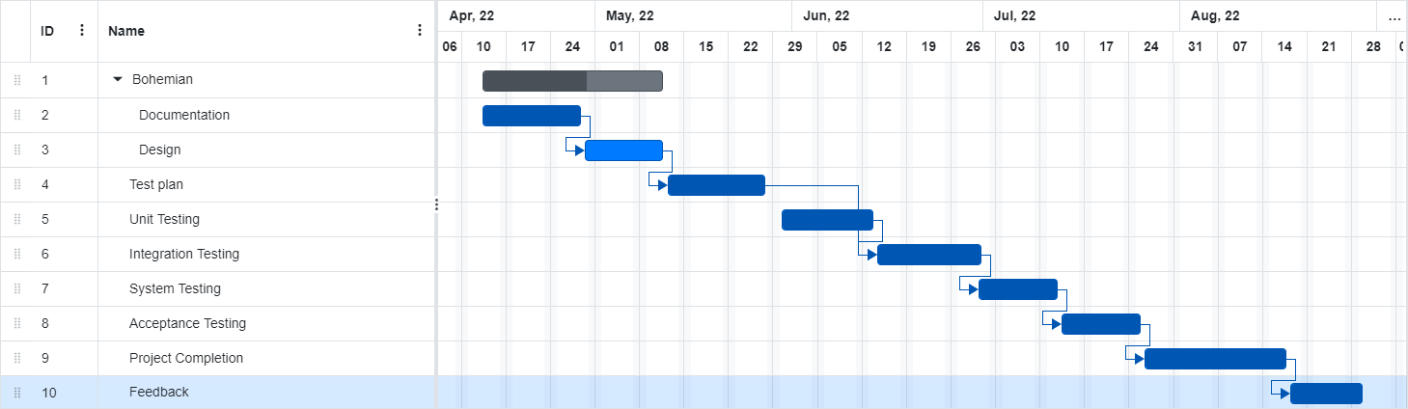

Fig: Gantt chart

# PLANNING RISKS AND CONTINGENCIES

* Changes in Requirements: Every feature should be agreed upon before work starts, and documentation should be retained. This will reduce the number of pointless modifications to the initial need. Failure to do so could lead to concessions like overtime work or a rise in the number of systemic defects that are accepted.
* Future Update: The software system needs to be adaptable enough to handle changes in the future and expand its capabilities. A prior agreement will be made for any required future expansions throughout the maintenance phase.
* Lack Of Resources: It can take longer to find personnel to review the required paperwork and take part in the acceptance test procedure due to a staffing shortage. Dates for review and acceptance testing will be advanced in line with any issues with client staff.

# APROVALS

|  |  |
| --- | --- |
| Project Sponsor | Md. Ahsan Nayem |
| Development Management | Prisila Saha |
| EDI Project Manager | Syeda Fariha Sultana |
| RS Test Manager | Prisila Saha |
| RS Development Team Manager | Md Ahsan Nayem |
| Reassigned Sales | Syeda Fariha Sultana |
| Order Entry EDI Team Manager | Ahsan Nayem |